CORIHS Supplement Form C: International Research

v. 5.31.17

Study ID #:  1255165-1     

PI Name: Small, Peter MD     

1. International Setting

a. Where is the research to be conducted? This study will be piloted in Pyuthan District of Central-Western Nepal (hills region). The bulk of the population is scattered in remote villages, accessible only by unpaved roads and footpaths that take many hours to traverse. The communities are characterized by a young age distribution, low literacy levels, high povery rates, and poor access to healthcare and sanitation. The DrOTS project will be gradually implemented across 12 villages, within 25 kilometers from the district hospital.

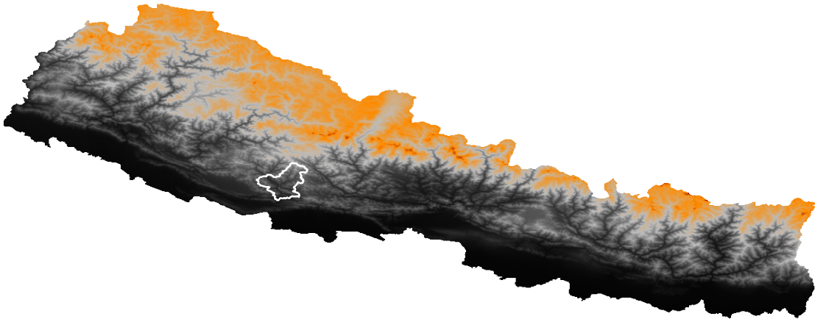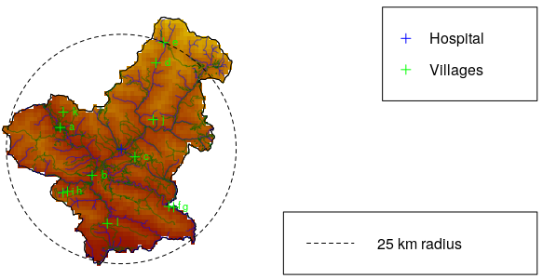     

b. Describe the specific cultural norms in this country with respect to research, ability of individuals to decide for themselves to consent to volunteering in research, age of majority, etc.:The implementation partner for this project, Birat Nepal Medical Trust, is a Nepal NGO with a history of over 50 years of public health work and research in Nepal. Working closely with the National Tuberculosis Control Programme, the BNMT carries out health interventions and research projects directly in the community, with offices in 6 of Nepal’s 7 provinces. BNMT is closely familiar with and experienced in the rules and norms regarding research consent and volunteering, having previously carried out TB Reach projects in 8 districts, Impact TB projects in 4, Americares in 1, and government partnerships in 20.

The age of consent in Nepal is 16. The population in the district of Pyuthan, where the project will take place, is familiar with the TB-related work of BNMT, and have been exposed to biomedical research. As part of this project, participants will be re-familiarized with BNMT as an organization and their role in Nepali TB research. They will be informed regarding consent fully, and will be made aware of the optional/voluntary nature of their participation.      

c. Review the ethical/legal requirements relevant to the international site, per [OHRP’s International Compilation of Human Subject Research Protections](http://www.hhs.gov/ohrp/international/index.html)

and [NIH’s website of International clinical research regulations](http://clinregs.niaid.nih.gov/index.php). **Cite the requirements and upload proof that these requirements have been met.**

There are no requirements for this international site.   

d. Will all of the subjects be fluent in English?

Yes  No -> describe how communication will take place with subjects:

The official language of Nepal is Nepali, though Newari and Khamkura are also regularly spoken in the Pyuthan area. Native bilingual Nepali/English translators will facilitate communication between the local population and non-Nepali researchers, if necessary. Written materials will be provided in Nepali, and explained orally in local languages when applicable (the literate population in Nepal knows Nepali).     

2. Consent

a. Describe if, and how, consent will be obtained from subjects:

Per Ministry of Health guidelines, CHWs already carry out active case finding in their districts. This involves following a MoH protocol for first carrying out oral screening for potential “suspect” cases based on reported symptoms, and then initiating the diagnostic process. The entire consenting process will take place after the oral screening and prior to the diagnostic process. The diagnostic process (sputum collection, data collection) will not take place unless informed consent is provided. In the case of a patient preferring not to consent, or being deemed by the study member incapable of providing consent, the patient will instead be enrolled in the standard MoH protocol for TB diagnosis and treatment. The doctor leading the research team ( accompanied by a translator if necessary) or a trained CHW, will obtain consent in one of two ways:

1. If the subject is literate, a form will be provided in Nepali for the subject to review and sign.
2. If the subject is illiterate, the form will be read to the subject in Nepali (and translated/explained, as applicable, in Newari or Khamkura), and a thumbprint will be used to sign acknowledge that the information on the form was read.

b. Describe how the investigators will ensure that subjects understand the nature of the research.

Consent forms and oral communication will be translated into the subject’s local dialect for convenience. After reading or being read the consent form, the subject will be asked to acknowledge if they understand the procedures involved in the study. They will be asked to confirm if they understand the risks involved, and the voluntary nature of their participation.    

c. If consent forms are to be used with non-English-speaking subjects, how will translations be obtained?

Written material will be translated from English to Nepali by the BNMT prior to beginning field work. For real-time translation, a team of Nepali translators employed by the BNMT will provide services.    

3. Expertise and Consultation

a. What are the investigator’s qualifications to conduct research **in this country**?

 Dr. Peter Small is the founding director of the Stony Brook University Global Health Institute. Prior to his appointment, he worked for the Bill and Melinda Gates Foundation for nearly 13 years, where he used his medical training in infectious diseases to develop the foundation’s strategy in fighting tuberculosis on a global scale, focusing on India. Dr. Small has frequently visited the country to learn the culture and norms surrounding healthcare and TB treatment in Nepali society.

b. Will the investigator be collaborating with local persons (e.g., researchers, universities, community leaders, etc.)?

No  Yes ->describe:

The study will be primarily based at the Stony Brook University-affiliated Birat Nepal Medical Trust research station in Pyuthan, Nepal (at the district hospital). This facility will be used for housing, transportation, and general research activities. BNMT will also be responsible for providing technicians and translators for expeditions.

The study will be done in full compliance and in conjunction with the Nepali National TB Program (NTP) and the Nepali Ministry of Health. All diagnostic testing will be done at an NTP-led laboratory, and treatment will be directed and provided by a doctor fully integrated in the local health system. The transportation of biological specimens will be compliant with regulations dictated by the Nepali Ministries of Health, Aviation, Defense, and Home.    

c. Will this research be reviewed by a local IRB or ethics committee?

No  Yes -> describe:

The BNMT will submit the research to the Nepali national ethics committee (submission pending). All activities will have been approved by appropriate ministries of the Nepali government.     and upload a copy of the current approval letter and approved consent document(s), if applicable.

d. Provide contact information (name, telephone #, e-mail address) for someone who can serve as a cultural consultant for your study. Include qualifications. The person should be familiar with the culture of the subject population and /or be able to verify that translated documents are the equivalent of the English version of the submitted documents:

Dr. Suman Chandra Gurung is a tuberculosis epidemiologist, with a long history of work in Nepal. Dr. Gurung is the Director of the Birat Nepal Medical Trust, and has also worked for the Internaional Organization for Migration and Nepali Ministry of Health..

Suman Chandra Gurung

Birat Nepal Medical Trust

scgurung@bnmt.org.np

Lazimpat Rd, Kathmandu 44600, Nepal    

->**Upload an attestation from this individual** certifying that the proposed research activity as written is sensitive to the cultural norms (detailed in question 1.b above) of the transnational site. Check to confirm: